The College of Dental Surgeons of Hong Kong | 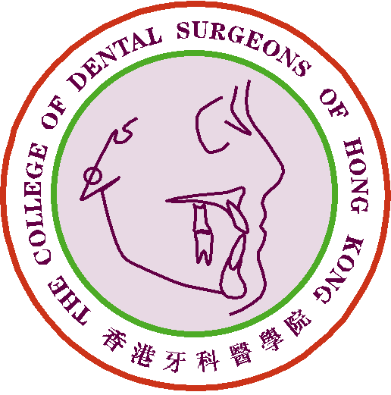

Claim Form for CME/CPD Programme

Personal Data |  | Date of Submission :
Name of Applicant : |  | Phone No.:
Email address: |  | Fax No.:

Please ☑ one only :
1) Fellow or Specialist |  |  | 2) MGD Holder |  |  | 3) Specialist Trainee

Reviewer of Journals
(Indexed journals, including HKMJ)
Date of Review:
Name of Journal:
Manuscript No.:
Letter of Review Submission / Certificate of Reviewer attached *
*(Please delete as appropriate)
No. of CME point(s) claimed:

For Official Use Only | Points Awarded:
For Official Use Only | Total | CME point(s)

- The CME Subcommittee has the rights to evaluate, approve, review and revise the CME point(s) for the above activity/activities.
- Please send this form and other supporting documents by e-mail: cme_cpd@cdshk.org to College for processing.

(Please make photocopies of these forms whenever applicable or download from
CDSHK website under “Forms Download”: http://www.cdshk.org/Forms/index.htm)

